EXPERIMENT NO. : 04

Q1. Write a JavaScript to design a simple calculator to perform the following operations: sum, product, difference.

HTML CODE :

<!DOCTYPE html>

<html lang="en">

<head>

    <meta charset="UTF-8">

    <meta name="viewport" content="width=device-width, initial-scale=1.0">

    <meta http-equiv="X-UA-Compatible" content="ie=edge">

    <link rel="stylesheet" href="Exp_04.css">

    <title>Calculator</title>

</head>

<body>

    <div class="container">

        <h1>Calculator</h1>

        <div class="calculator">

            <input type="text" name="screen" id="screen">

            <table>

                <tr>

                    <td><button onclick="display('(')">(</button></td>

                    <td><button onclick="display(')')">)</button></td>

                    <td><button onclick="Clear()">C</button></td>

                    <td><button onclick="display('%')">%</button></td>

                </tr>

                <tr>

                    <td><button onclick="display('7')">7</button></td>

                    <td><button onclick="display('8')">8</button></td>

                    <td><button onclick="display('9')">9</button></td>

                    <td><button onclick="display('*')">X</button></td>

                </tr>

                <tr>

                    <td><button onclick="display('4')">4</button></td>

                    <td><button onclick="display('5')">5</button></td>

                    <td><button onclick="display('6')">6</button></td>

                    <td><button onclick="display('-')">-</button></td>

                </tr>

                <tr>

                    <td><button onclick="display('1')">1</button></td>

                    <td><button onclick="display('2')">2</button></td>

                    <td><button onclick="display('3')">3</button></td>

                    <td><button onclick="display('+')">+</button></td>

                </tr>

                <tr>

                    <td><button onclick="display('0')">0</button></td>

                    <td><button onclick="display('.')">.</button></td>

                    <td><button onclick="display('/')">/</button></td>

                    <td><button onclick="del()">Del</button></td>

                </tr>

                <tr>

                    <td><button onclick="square()">X <sup>2</sup></button></td>

                    <td><button onclick="cube()">X <sup>3</sup></button></td>

                    <td colspan="5"><button onclick="Calculate()" class="sub">=</button></td>

                </tr>

            </table>

        </div>

    </div>

    <footer>

        <h5 class = "footer"> &#169; Harvande Sanket@2021</h5>

    </footer>

</body>

<script src="Exp_04.js"></script>

</html>

CSS CODE :

body{

*background-color*: rgb(206, 172, 141);

}

.container{

*text-align*: center;

*margin-top*:23px

}

table{

*margin*: auto;

}

input{

*border-radius*: 8px;

*border*: 6px solid #703708;

*font-size*:34px;

*height*: 65px;

*width*: 365px;

}

button{

*border-radius*: 8px;

*font-size*: 40px;

*background*: #fa7d0f;

*width*: 82px;

*height*: 61px;

*margin*: 6px;

}

button.sub {

*width*: 178px;

}

.calculator{

*border*: 4px solid #703708;

*background-color*: #e7c67e;

*padding*: 23px;

*border-radius*: 20px;

*display*: inline-block;

}

h1{

*font-size*: 28px;

*font-family*: sans-serif;

*font-size*: 50px;

*font-variant*: small-caps;

*font-family*: -apple-system, BlinkMacSystemFont, 'Segoe UI', Roboto, Oxygen, Ubuntu, Cantarell, 'Open Sans', 'Helvetica Neue', sans-serif;

}

.footer{

*text-align*: right;

}

JAVASCRIPT CODE :

let outputScreen = document.getElementById("output-screen");

function display(num) {

    outputScreen.value += num;

}

function Calculate() {

    try {

        outputScreen.value = eval(outputScreen.value);

    } catch (err) {

        alert("kya ENGINEER banega re tu")

    }

}

function Clear() {

    outputScreen.value = "";

}

function del() {

    outputScreen.value = outputScreen.value.slice(0, -1);

}

OUTPUT:

1. Addition :

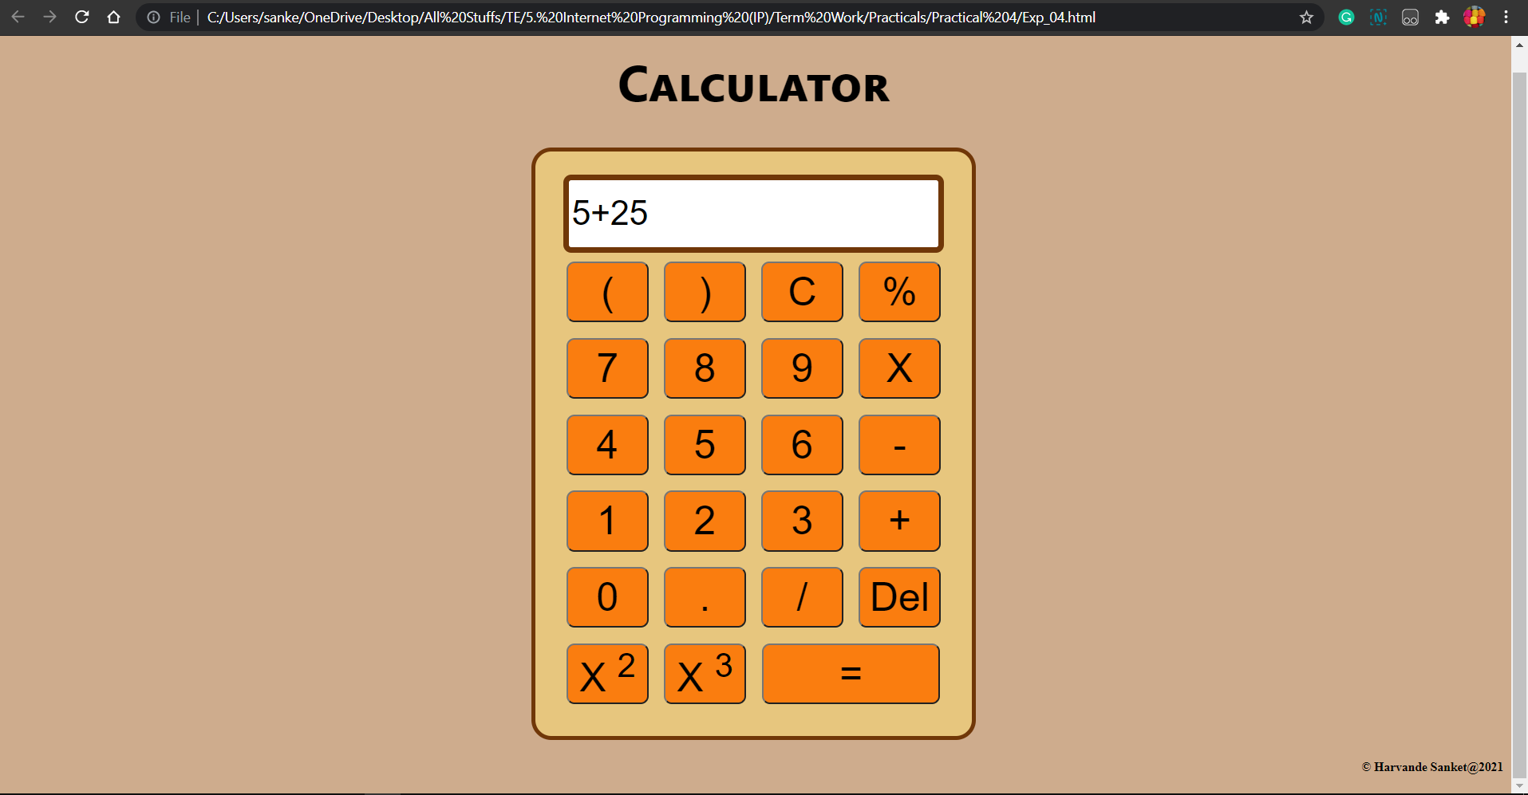

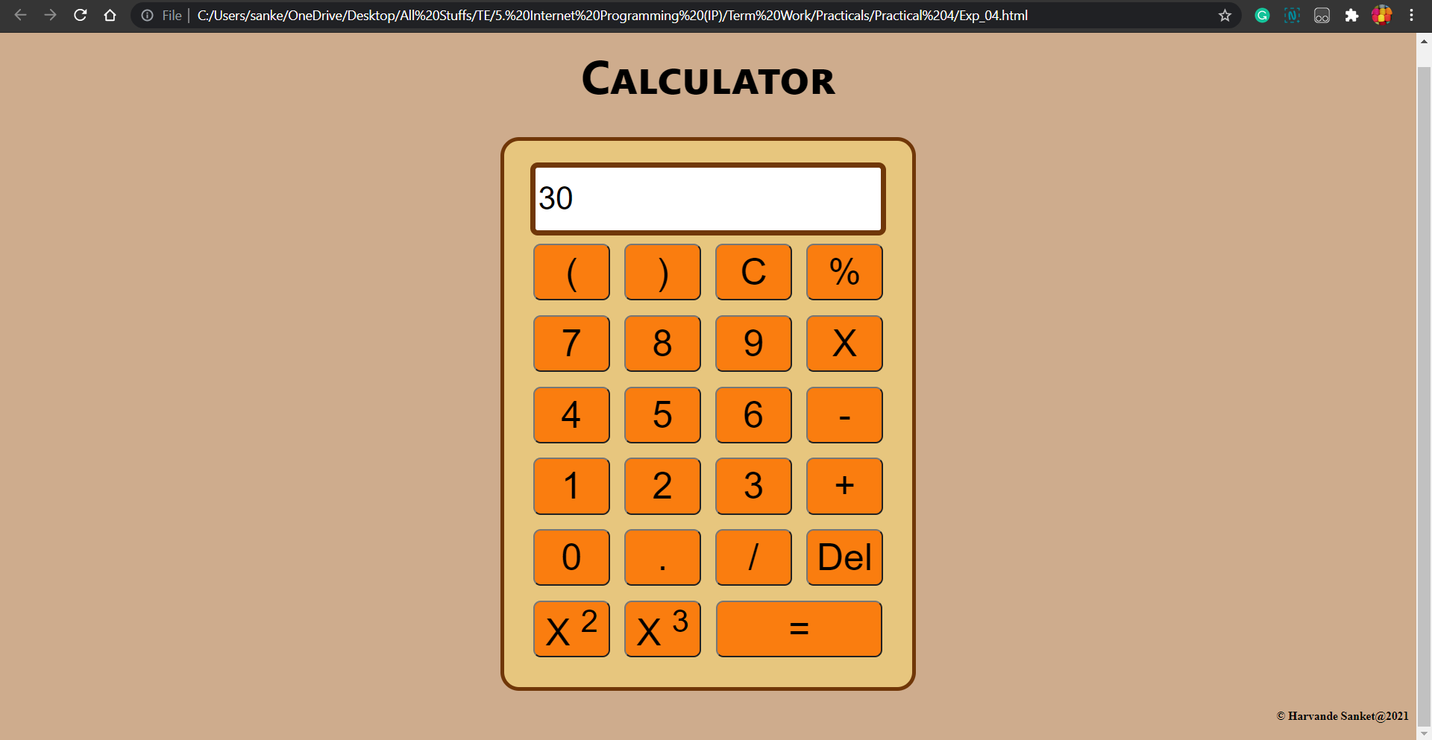

2) Subtraction :

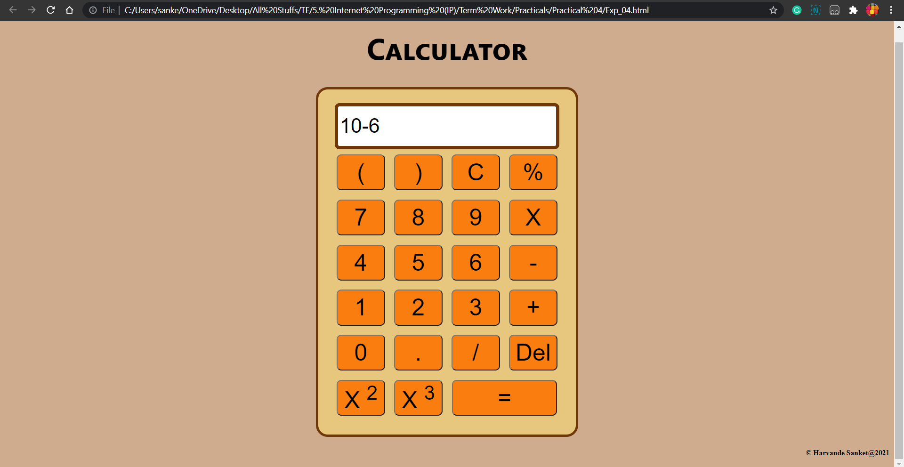

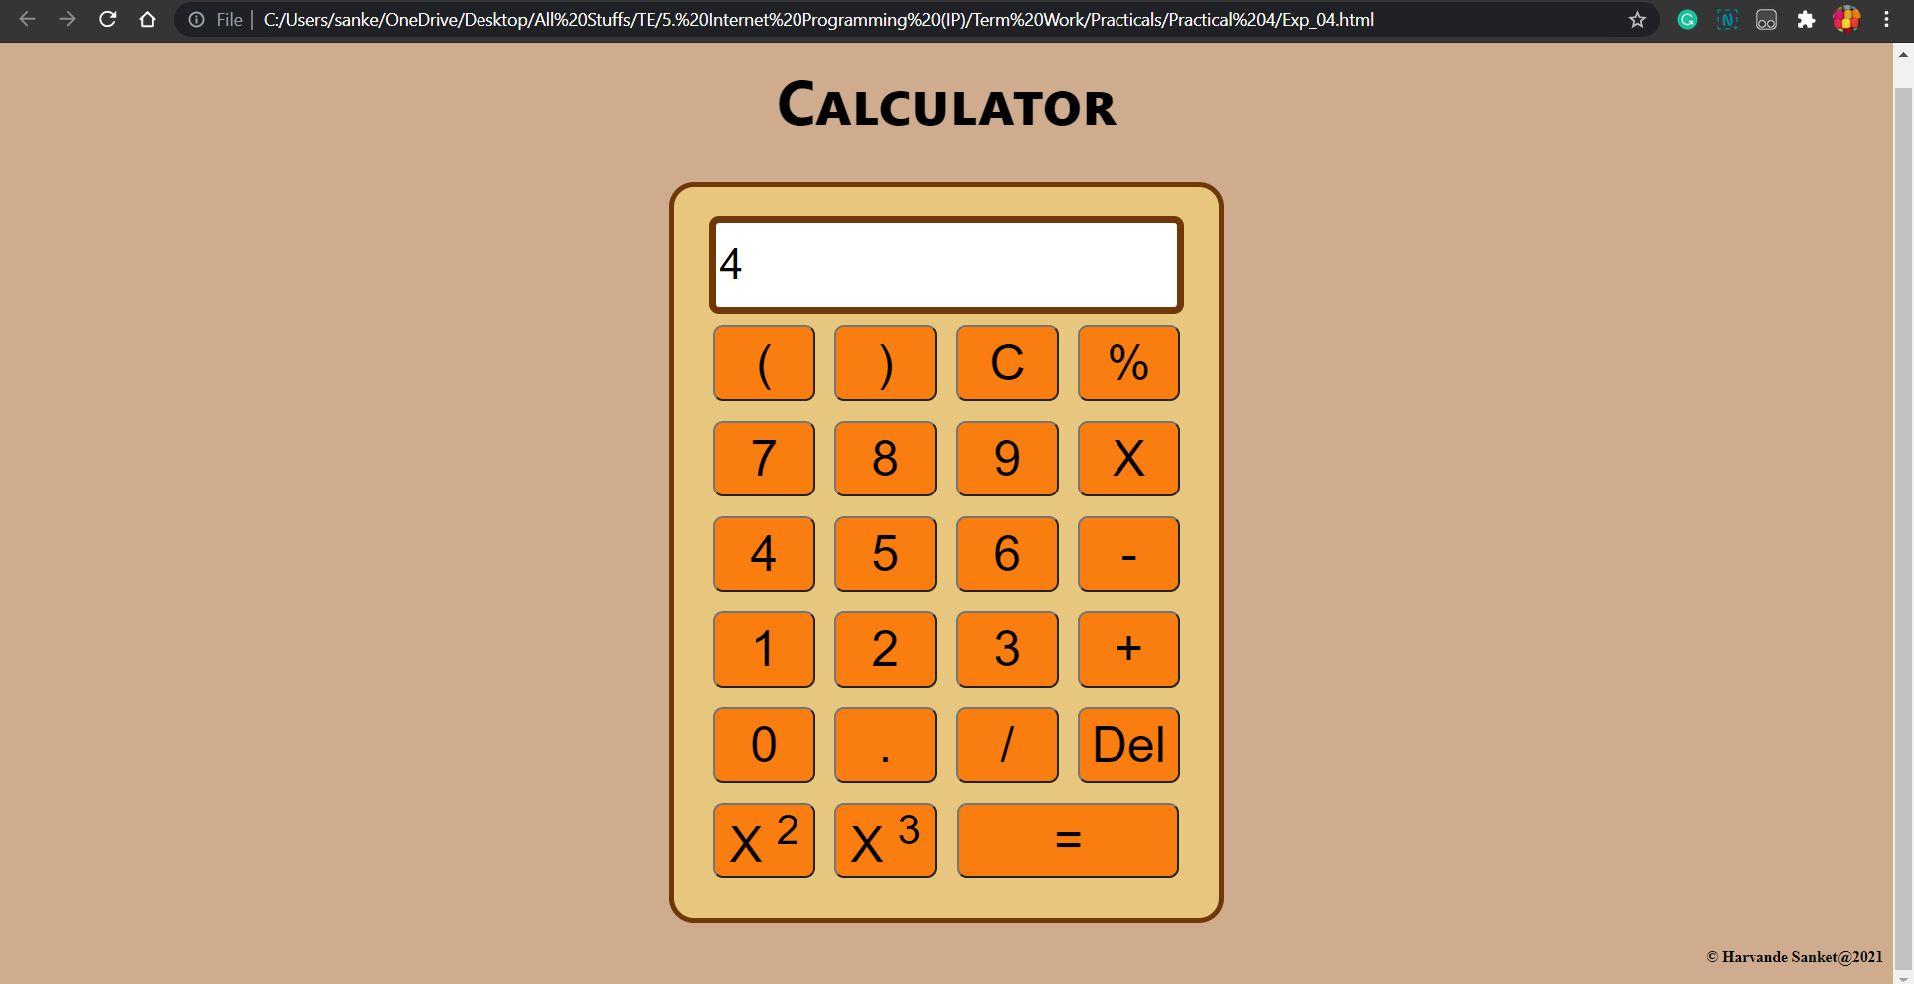

3) Multiplication :

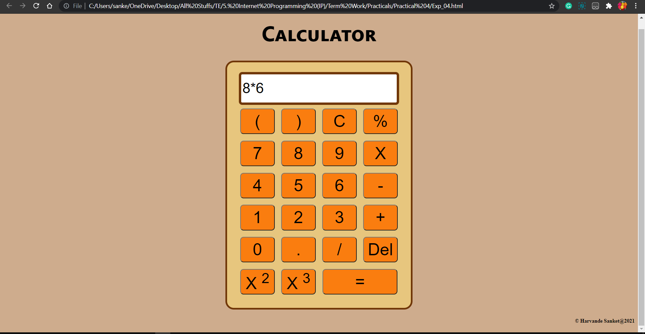

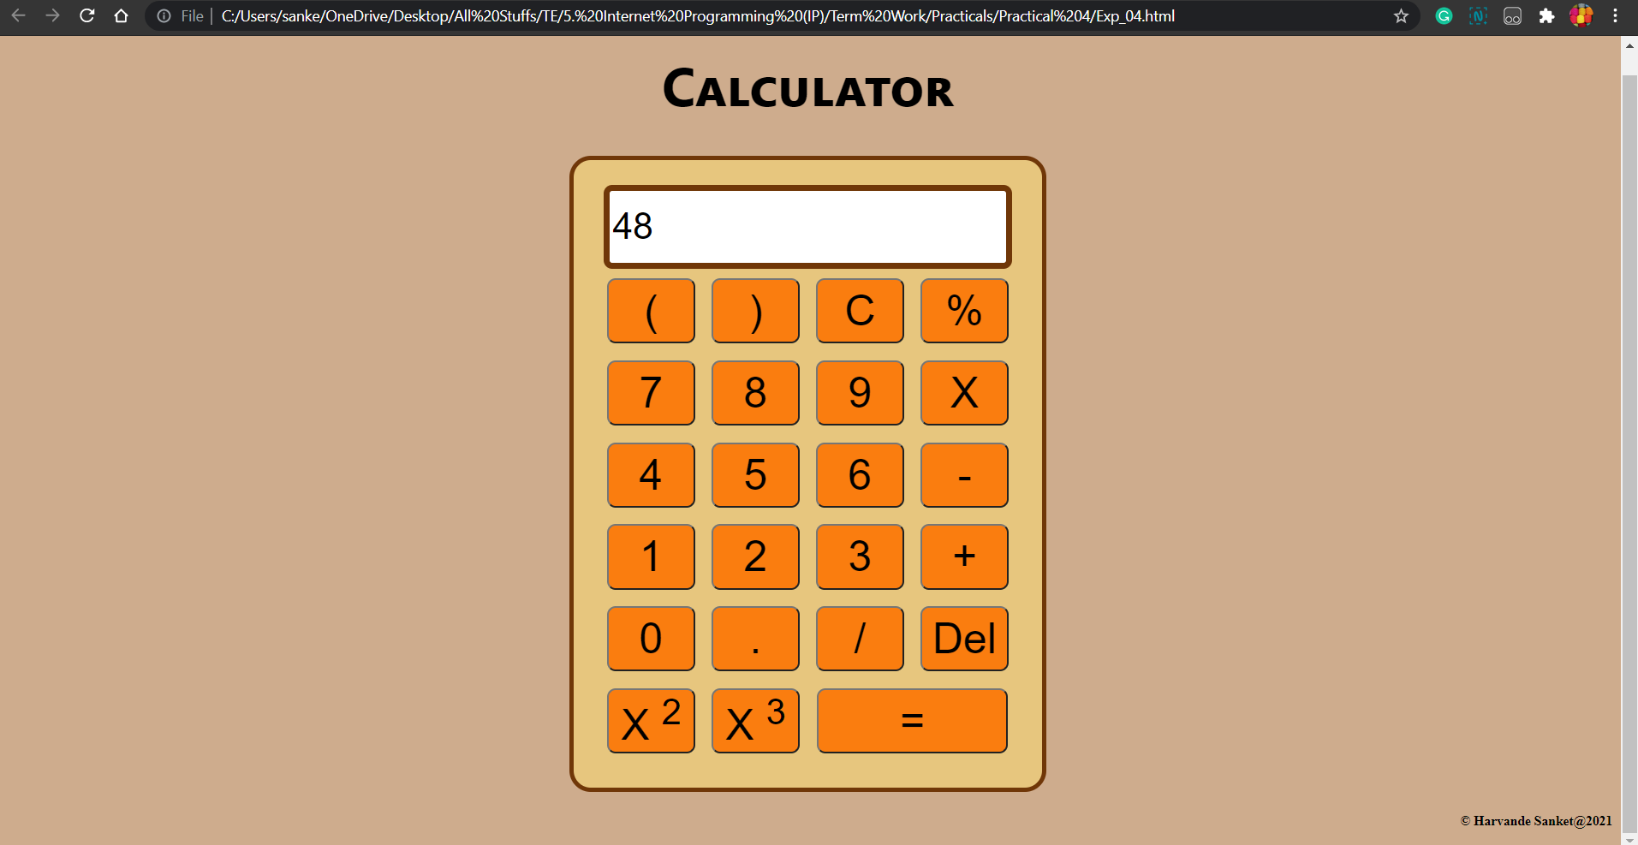

4) Division :

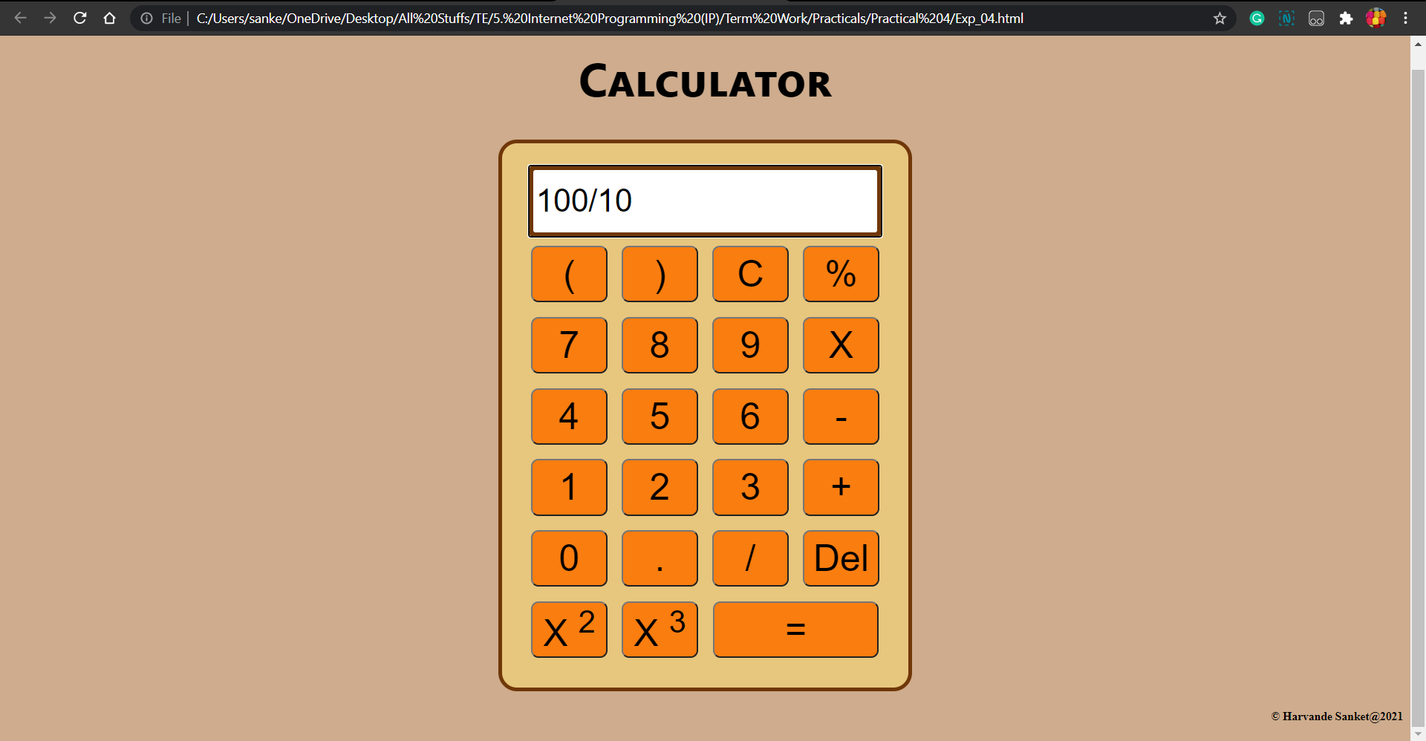

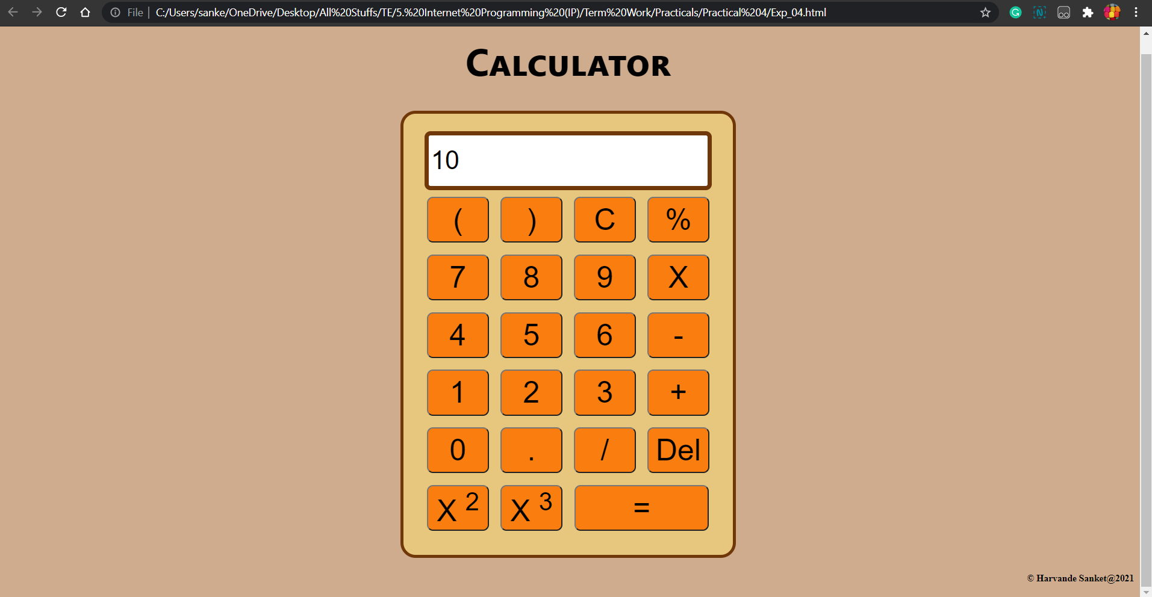

5) Invalid input message :

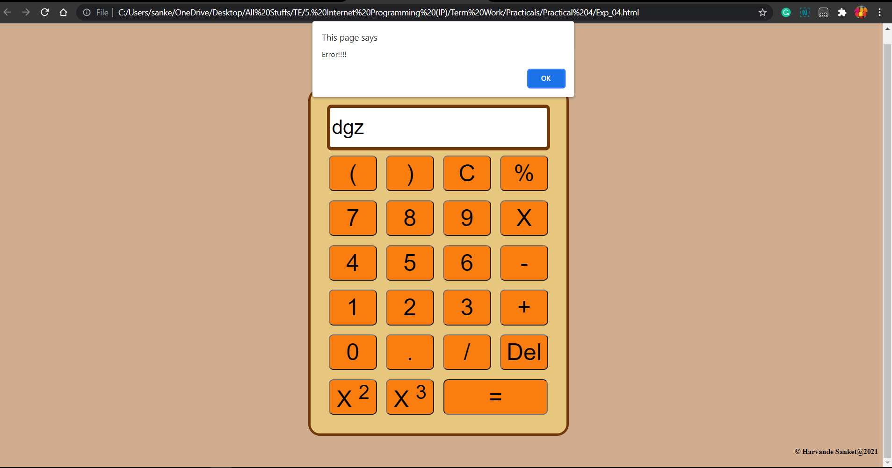

Q2.  Write a JavaScript that calculates the squares and cubes of the numbers from 0 to 10 and outputs HTML text that displays the resulting values in an HTML table format.

Html, css & Javascript :

<!DOCTYPE html>

<html lang="en">

<head>

    <meta charset="UTF-8">

    <meta http-equiv="X-UA-Compatible" content="IE=edge">

    <meta name="viewport" content="width=device-width, initial-scale=1.0">

    <title>Program 2 - 0-10 Square and Cubes</title>

    <style>

        table {

            color: #333;

            font-family: Helvetica, Arial, sans-serif;

            width: 640px;

            border-collapse: collapse;

            border-spacing: 0;

        }

        td,

        th {

            border: 1px solid #CCC;

            height: 30px;

        }

        th {

            background: green;

            font-weight: bold;

        }

        td {

            background: #d88181;

            text-align: center;

        }

        body {

            text-align: center;

            font-style: italic;

        }

    </style>

</head>

<body>

    <h1>Experiment No.04</h1>

</body>

<script>

    document.write("<center><table> <tr> <th>Number</th> <th>Square</th> <th>Cube</th> </tr>")

    for (var n = 0; n <= 10; n++) {

        document.write("<tr><td>" + n + "</td><td>" + n * n + "</td><td>" + n * n * n + "</td></tr>")

    }

    document.write("</table></center>")

</script>

</html>

OUTPUT :

